Credit Card Segmentation- Case Study

- Purchases are highly positively correlated to credit limit and payments
- Balance is highly positively correlated to payments, credit limit, cash advance but highly negatively correlated to % of months with full payment of due balance
- Purchase frequency is highly negatively correlated to cash advance frequency
- Installment frequency is also negatively correlated to cash advance frequency
- Credit limit is almost positively correlated with everything
- Also optimal k from the elbow method came out to be 10. Therefore 10 clusters were formed

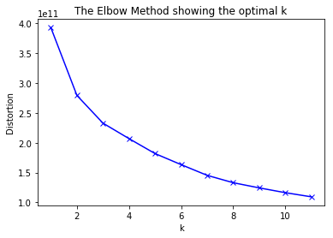

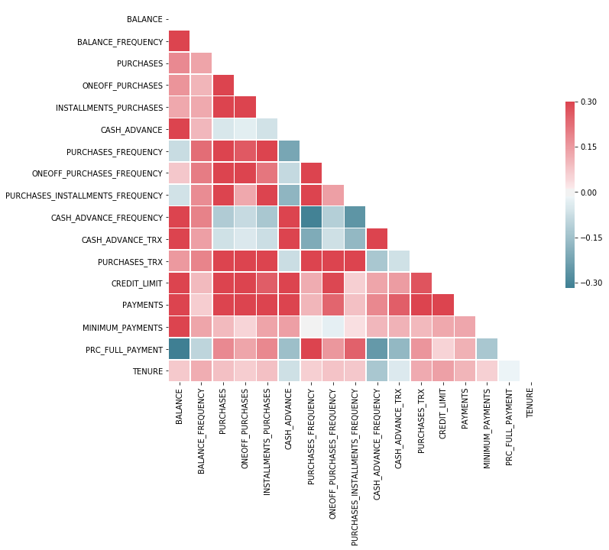
The Correlation Heat Map

